Name Alex Lundin

Class SE 4367.001 - Software Testing

Assignment Homework #3

Cycolmatic Complexity

1. V(G) = 6

V(G) = E –N + 2(P)

Formula used for simple routine where P is always 1

V(G) = 15 –11 + 2(1)

V(G) = 4 + 2

V(G) = 6

1. V(G) = 6

**See second page for full control flow graph**

**See third page for control flow graph with decisions ONLY, D1 through D4**

**Full Control Flow Graph**

Total number of nodes:

15

Total number of edges:

11

V(G) = E –N + 2(P)

Formula used for simple routine where P is always

V(G) = 15 –11 + 2

V(G) = 4 + 2

V(G) = 6

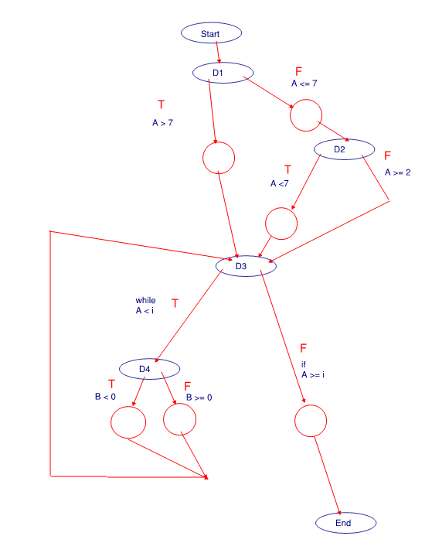

**Decisions ONLY Control Flow Graph Work**

Number of decisions 4:

D1 - Line 4

D2 -Line 11

D3 -Line 15

D3 part 2 –standard piece of for loop

D4 -Line 1

Number of entry nodes 1:

Start - Line 1

Number of exit nodes 1:

Exit -Line 28

Total number of decision nodes:

6

Total number of edges on decision nodes:

V(G) = E –N + 2(P)

Formula used for simple routine where P is always

V(G) = 10 –6 + 2

V(G) = 4 + 2

V(G) = 6

**Decisions ONLY Control Flow Graph**

